With all the chatter about social contracts in the media today, we decided to take a look at the relative freedom indices of countries around the world. To be clear, let it be known that there are still extremely affluent countries and provinces where political and economic freedom is diminished. For instance, Dubai still does not have voting in place. However, it attracts wealthy tourists from around the world.

India, while in theory democratized and secular as per its constitution, frequently confronts the issue of compromises at the fringes. And faces a challenge of unifying its many diverse cultures. While China has been more brazen about the Han Chinese’s upper hand, to the detriment of populations such as the Uighers, India has been more careful in doing so. Although it too has shown the exclusion of Muslim minorities in recent times. Much to the chagrin of India’s large historic Muslim population. With India’s many iterations of cultural overwriting – renaming Bombay to Mumbai – the saffronization of India’s Mughal landmarks is a challenging, and potentially futile motive to accomplish.

However, the message has been sent. When the suggestion came to rename Khan Market, one of South Delhi’s most upscale open-air strip mall style markets from the past decades, there was major pushback.

**WORD CLOUD COMPARISONS:**

A word cloud is not a very robust tool for analysis. However, when we glance at word clouds for these two massive countries (based on population sizes) what comes to mind? And can we decipher from them? How do emphases determine outcomes in the two countries? And to what extent are the foundational values still being put in practice – as ends to continually strive towards?

These are questions that arise not only with respect to governments and their constitutions, but also when thinking of companies, and the values they were founded upon. The concept of ‘mission drift’ comes to mind. Applied mostly when talking about non-profits, this term refers to high overhead and salary packages for the board of a non-profit that has taken off and is thriving financially. With plenty of donors and growth opportunities.

Mission drift almost surely occurs with countries as well, most often, when going from the less developed state to the more developed one.

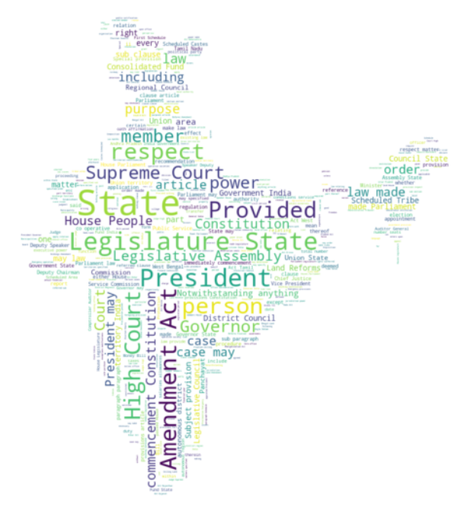

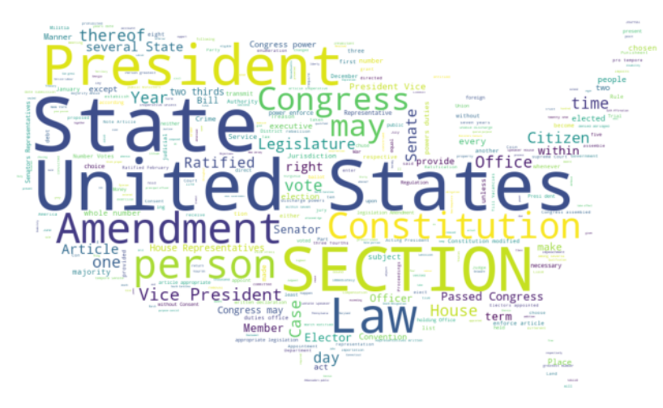

Comparison of word frequency between constitutions:

For India, the top 5 words are: ‘State’, ‘Amendment Act’, ‘President’, ‘Provided’, ‘Legislature State’

For the US, the top 5 recurring words are: ‘United States’, ‘State’, President’, ‘Section’, ‘Amendment’.

What I find truly notable about both constitutions is the inclusion of the word ‘Amendment’ as one of the most frequently occurring words. In essence, a testimony to the living document nature of our constitutions.

What I find disheartening however, is that while the US constitution features mention of the Vice President as some who may check the power and complement the chief executive, the Indian constitution rarely mentions the Prime Minister. In India, the Prime Minister, or PM really is the chief executor of all branches of government. The Indian constitution mentions the PM but 8 times, whereas it mentions the President over 400 times! I don't even know the president's name. Is this a prime (forgive the pun) example of 'mission drift'? And does it need to be amended?

**FREEDOM INDICES**

In the following map, no surprises, data pulled from sources such as Cato and Reporters without borders shows that the human freedom index scores for countries with highly authoritarian regimes negatively correlate with countries considered free.

Conversely, countries with consolidated democracy systems generally strongly correlate with free countries on the human freedom index.

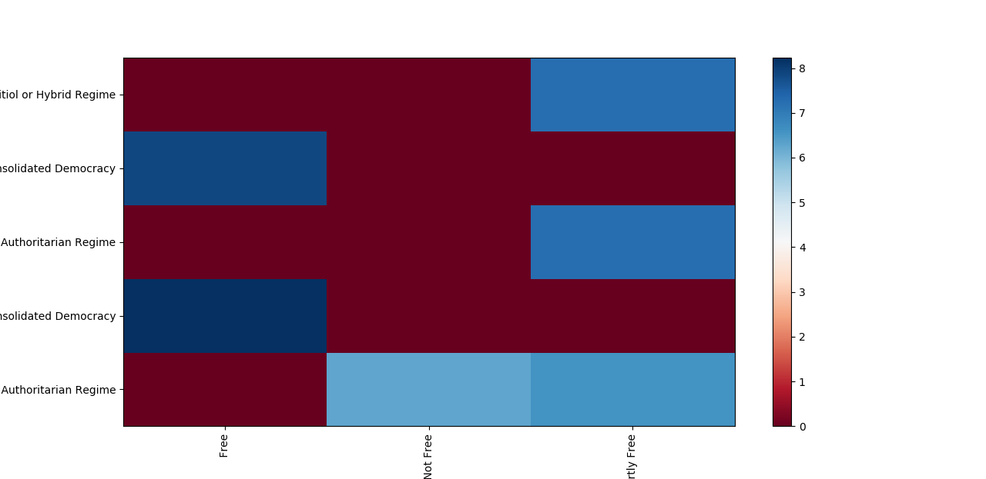

The hypothesis that democratic countries and authoritarian regimes score differently on measures of human freedom is not a surprising one. Though it is testable using data available from sources such as freedom house. And can be plotted in the form of a regression using python’s seaborn package.

**CONCLUSION**

There more research to be done on whether greater political freedom and systems of political organization lead to greater economic prosperity or distributions of wealth. But as an end unto itself, the pursuit of human freedom can clearly be achieved through a democratic organization. In other words, authoritarian regimes may or may not enhance economic well being, but they rarely increase human freedom. Meanwhile democracies that enhance human freedom without improving economic well-being may be questionable. What comes first? The increased economic well being of man under limited freedom? Or improved human freedom as a path to prosperity? The many national experiments working in tandem will serve to tell. We should surely hope human freedom precludes economic prosperity. So that the dynamic effects of prosperity can be sustained and enjoyed in the time to come. While rigid strictures and specialization that mimic monocropping may be hard to maintain after the global markets have evolved. Time will tell, and exports will adapt to reflect the same. Who swim above the tide? And is this all a zero-sum game? One hopes the American win-win motto sustains in a world rapidly polarized by the adoption of technology.